**1. Write a C++ Program to print "Hello, World!"**

**PROGRAM**

#include <iostream>

int main () {

std::cout << "Hello World!";

return 0;

}

**OUTPUT:**

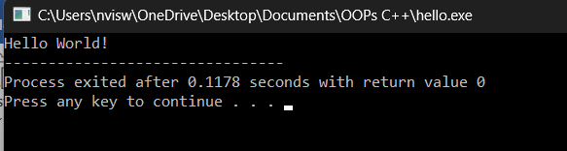

**2.** **Write a C++ Program to Print the Number Entered by the User**

**PROGRAM**

#include <iostream>

using namespace std;

int main () {

int number;

cout << "Enter an integer: ";

cin >> number;

cout << "You entered " << number;

return 0;

}

**OUTPUT**

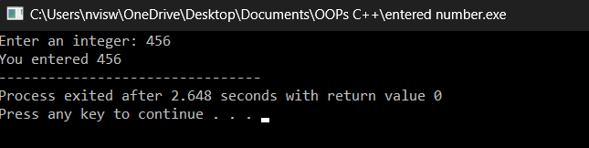

**3. Write a C++ Program to Add Two Numbers**

**PROGRAM**

#include <iostream>

using namespace std;

int main() {

int first_number, second_number, sum;

cout << "Enter two integers:\n";

cin >> first_number >> second_number;

sum = first_number + second_number;

cout << first_number << " + " << second_number << " = " << sum;

return 0;

}

**OUTPUT**

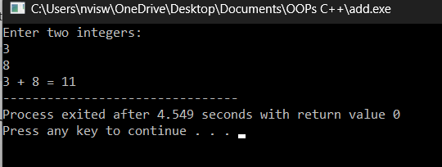

**4.** **Write a C++ Program to Find Quotient and Remainder**

**PROGRAM**

#include <iostream>

using namespace std;

int main()

{

int divisor, dividend, quotient, remainder;

cout << "Enter dividend: ";

cin >> dividend;

cout << "Enter divisor: ";

cin >> divisor;

quotient = dividend / divisor;

remainder = dividend % divisor;

cout << "Quotient = " << quotient << endl;

cout << "Remainder = " << remainder;

return 0;

}

**OUTPUT**

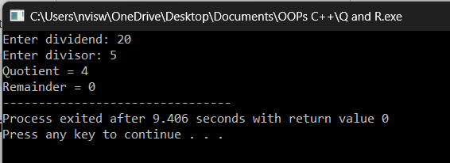

**5.** **Write a C++ Program to Find the Size of int, float, double, and char in Your System**

**PROGRAM**

#include <iostream>

using namespace std;

int main()

{

int integerType;

char charType;

float floatType;

double doubleType;

cout << "Size of int is: " << sizeof(integerType) << "\n";

cout << "Size of char is: " << sizeof(charType) << "\n";

cout << "Size of float is: " << sizeof(floatType) << "\n";

cout << "Size of double is: " << sizeof(doubleType) << "\n";

return 0;

}

**OUTPUT**

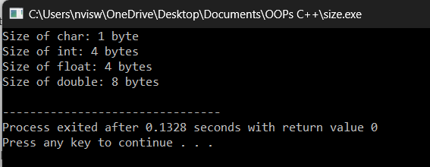

**6.** **Write a C++ Program to Swap Two Numbers**

**PROGRAM**

#include <iostream>

using namespace std;

int main()

{

int a = 5, b = 10, temp;

cout << "Before swapping." << endl;

cout << "a = " << a << ", b = " << b << endl;

temp = a;

a = b;

b = temp;

cout << "\nAfter swapping." << endl;

cout << "a = " << a << ", b = " << b << endl;

return 0;

}

**OUTPUT**

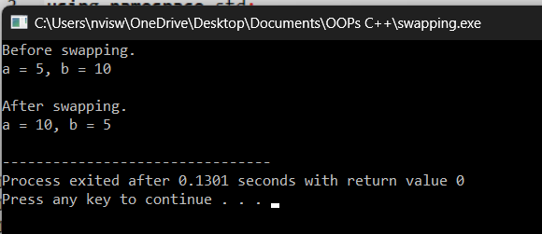

**7.** **Write a C++ Program to Check Whether Number is Even or Odd**

**PROGRAM**

#include<iostream>

using namespace std;

int main()

{

int num;

cout<<"enter the number:";

cin>>num;

if(num%2==0){

cout<<"even number";

}

else

{

cout<<"odd number";

}

return 0;

}

**OUTPUT**

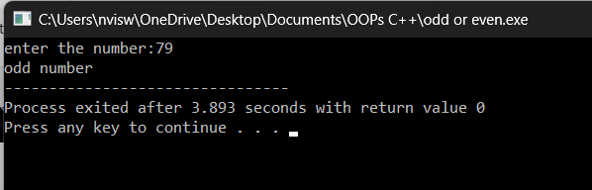

**8.** **Write a C++ Program to Check Whether a character is Vowel or Consonant.**

**PROGRAM**

#include<iostream>

using namespace std;

int main()

{

char ch;

cout<<"enter a character:";

cin>>ch;

if(ch=='a'||ch=='e'||ch=='i'||ch=='o'||ch=='u'){

cout<<"character is a vowel";

}

else{

cout<<"character is a consonant";

}

return 0;

}

**OUTPUT**

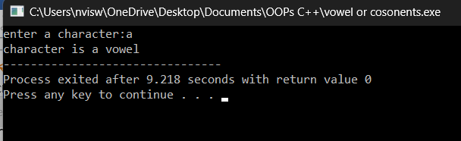

**9.** **Write a C++ Program to Find Largest Number Among Three Numbers**

**PROGRAM**

#include <iostream>

using namespace std;

int main() {

double n1, n2, n3;

cout << "Enter three numbers:\n ";

cin >> n1 >> n2 >> n3;

if(n1 >= n2 && n1 >= n3)

cout << "Largest number: " << n1;

else if(n2 >= n1 && n2 >= n3)

cout << "Largest number: " << n2;

else

cout << "Largest number: " << n3;

return 0;

}

**OUTPUT:**

